Pandemic Aftermath; Sustainable Food System
14th June, 2021

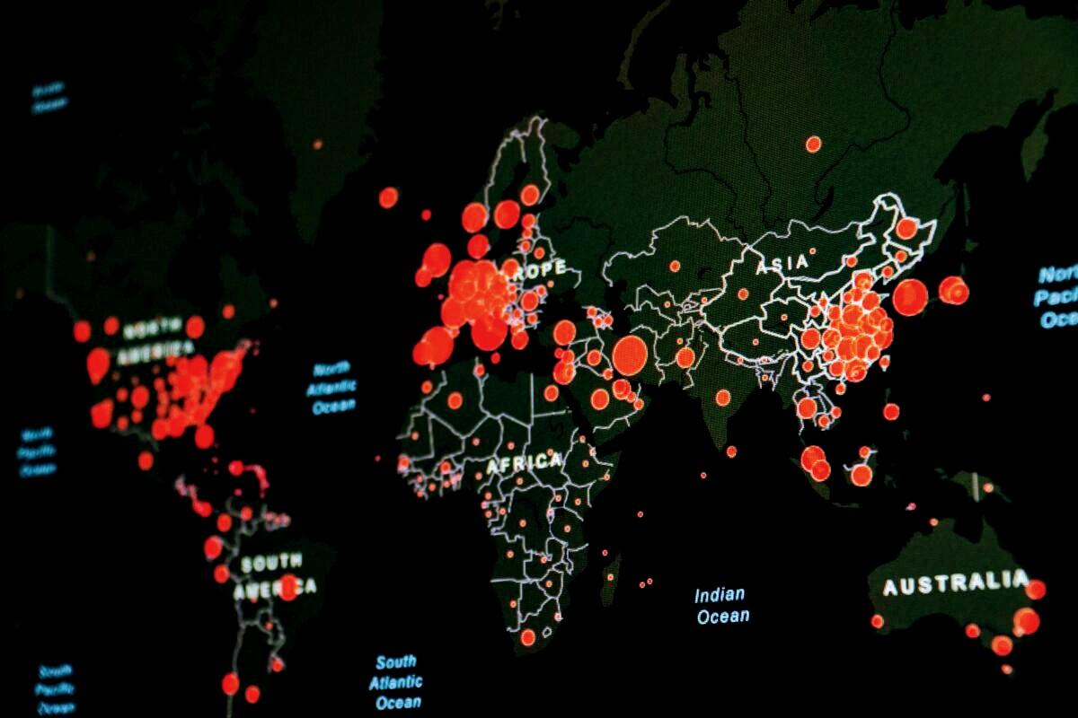

Prologue
- - - - X
Coronaviruses, similar to the one that causes COVID-19, are thought to spread for the most part individual-to-individual through respiratory beads when somebody hacks, sniffles, or talks. It is conceivable that an individual can get COVID-19 by contacting a surface or item, including food or food bundling, that has the infection on it and afterward contacting their own mouth, nose, or perhaps their eyes.

Relationship; Food and COVID-19
- - - - X
The danger of becoming ill with COVID-19 from eating or taking care of food (counting frozen food and produce) and food bundles is considered very low.The hazard of getting COVID-19 from food you cook yourself or from taking care of and burning-through food from cafés and takeout or drive-through dinners is believed to be extremely low. As of now, there is no proof that food is related to spreading the infection that causes COVID-19.
The danger of disease by the infection from food items, food bundling, or sacks is believed to be extremely low. Right now, no instances of COVID-19 have been distinguished where disease was thought to have happened by contacting food, food bundling, or shopping sacks. Although a few groups who work in food creation and preparing offices have gotten COVID-19, there is no proof of the infection spreading to buyers through the food or bundling that specialists in these offices may have dealt with.
However there is no proof that the infection that causes COVID-19 spreads to individuals through food. Nonetheless, securely handle and keep on cooking food sources to their prescribed cooking temperatures external symbol to forestall foodborne ailment.
The infection that causes COVID-19 has not been found in drinking water. The Environmental Protection Agency directs water treatment plants to guarantee that treated water is protected to drink.
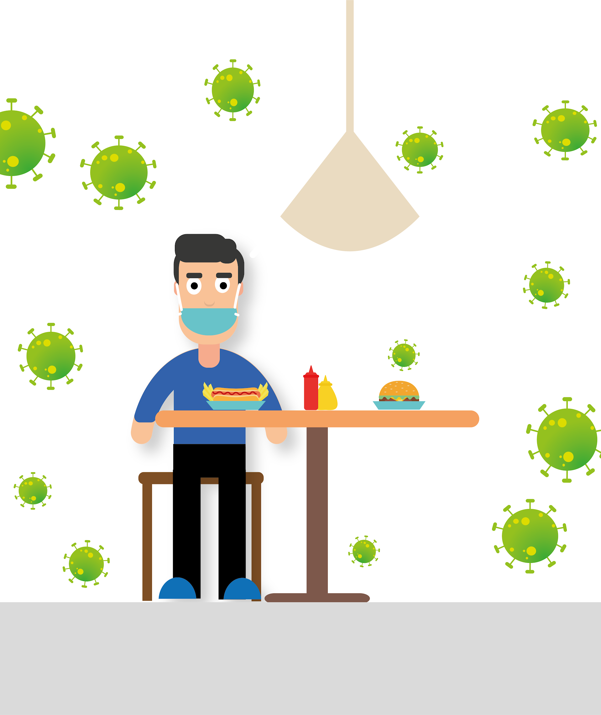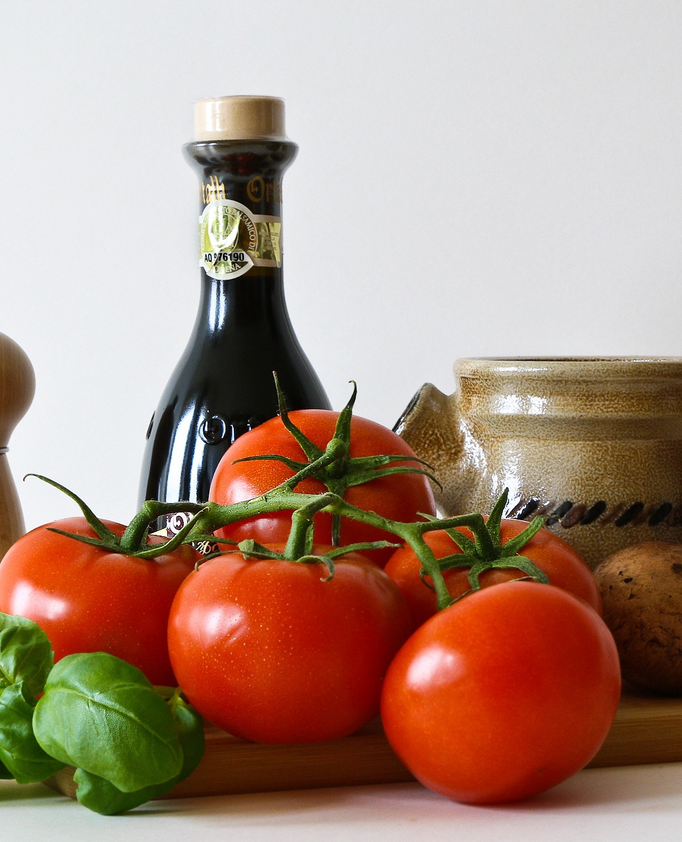

World's situation right now
As the spread of COVID-19 expands in less developed countries, policymakers will face an additional challenge that was largely absent in more developed economies – the informal sector. In a traditional economic downturn, the informal sector serves as a buffer to negative shocks, temporarily absorbing the workforce pushed out of the formal sector. However, under these unprecedented circumstances with many countries on the verge of a complete shut-down, the vulnerabilities of the informal sector will likely exacerbate the crisis. On one hand, effective enforcement of social distancing policies will take away the only means of survival for millions of the world’s poorest. On the other hand, if this segment of the economy remains in operation, we risk worsening the pandemic with an enormous human toll.
Four out of five shippers at a significant organic product market in Peru have tested positive for Covid, uncovering stunning degrees of disease – and inciting fears that Latin America's conventional exchanging focuses may have helped spread Covid-19 across the district. 79% of slow down holders in Lima's discount organic product
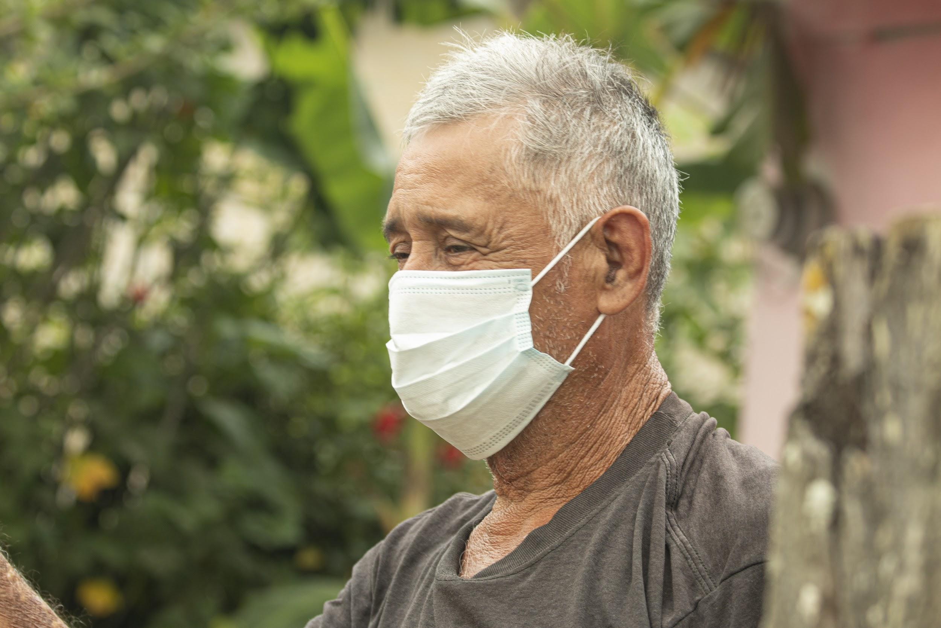
market tried positive for Covid-19, while spot tests at five other huge new food markets in the city uncovered essentially half were conveying the infection. The outcomes came as neighborhood specialists from Mexico City to Rio de Janeiro battle to uphold social separating and clean measures at discount and retail showcases, which are backbones of nearby economies.
Complications and Solutions
Coronavirus has not just exacerbated an all around delicate food security setting on the planet, but also has added another complex layer to other food security dangers, for example, environmental change, crop deficiencies, struggle and financial log jams and slumps. The COVID-19 pandemic is a general wellbeing emergency, yet there are extensive dangers that it can transform into a food emergency except if governments make critical moves to secure the most defenseless, and moderate the pandemic's
effects on horticulture and food frameworks. Numerous nations in the world are import-subordinate, particularly for food and agrarian data sources.
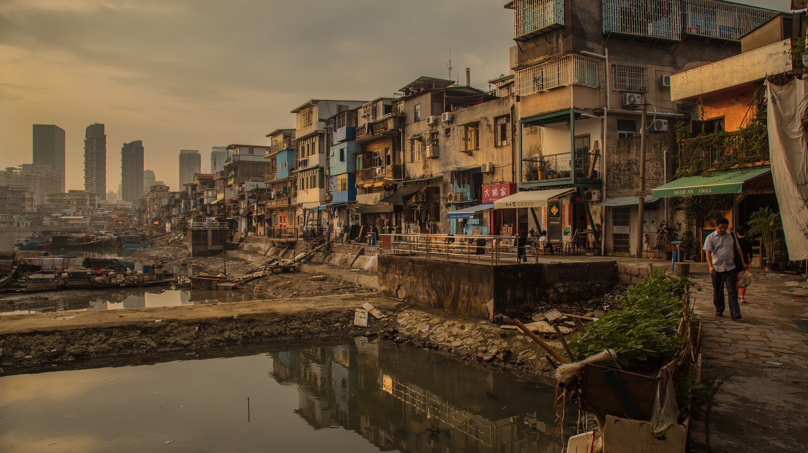
Simultaneously, these nations' trades are slanted toward agrarian items. The reliance on restricted rural fares builds the danger of a few nations' GDP to wear value shocks or dangers of compressions in worldwide interest. Then again, when such nations' exchange accomplices force send out limitations, the nations lose admittance to essential wares.
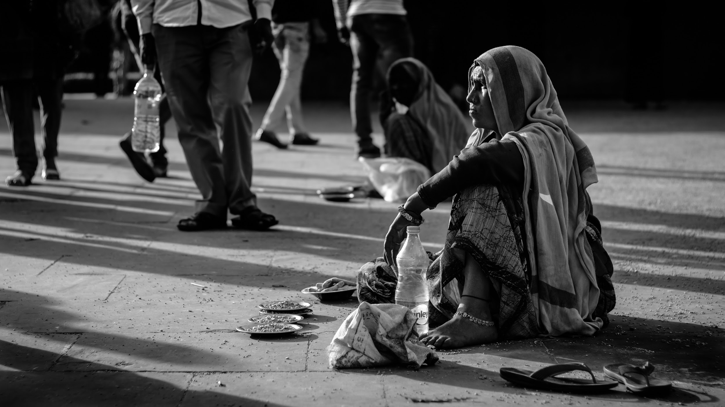
The COVID-19 episode offered the chance for a reflection on the significance of versatility in crises. Supportable and sound eating regimens for all, was shown, during the pandemic, to depend substantially more on friendly and monetary conditions than on specialized parts of food creation and preparing. Horticulture and the agro-business have now a possibility to retain the laborers spread out in other areas. The pandemic could be a chance to reexamine and re-establish work connections in the area just as nearby creations and supply chains.

A full circularity in food frameworks likewise would profit with more grounded joins set up at the regional level and increment the consideration on the nature of the climate, prompting the selection of benevolent works on, recovering instead of devastating normal assets.Diversity is a vital segment of a tough framework, both in the biophysical circle and in the social circle: new plans of action, new information sharing organizations, new business sectors. The three advances would work in collaboration and add to the flexibility of the entire food framework and it's anything but a potential next crisis.
Epilogue
Food is critical to individual wellbeing, just as to the soundness of the planet given that current examples of food creation and utilization have significant ecological effects. Making a strong eating routine is imperative during the COVID-19 pandemic. What we eat and drink can impact our body's ability to prevent, fight and recover from infections. While no food sources of dietary upgrades can thwart or fix COVID-19 illness, sound weight control plans are critical for supporting safe structures. So having the choice to consume great food assortments but the condition by and by is unpleasant, could result in the pandemic to have next to no terrible effects on humankind.

